

BATCH AND ROLL NO:
EXPERIMENT NO.8
TITLE: Design a mobile application for media player.
DATE OF PERFORMANCE
DATE OF CHECKING

Title: Design a mobile application for media player.

Requirements:
1 Android studio

Theory:
An Android media player app is an application that enables users to play and manage audio or video files on their Android devices. These apps typically provide a user interface for users to browse their media library, select a file to play, and control playback using on-screen controls or physical buttons. android media player apps can support a variety of media formats, including popular formats such as MP3, MP4, and WAV, as well as less common formats such as FLAC or Ogg Vorbis. Android media player apps are typically developed using the Android SDK and can be created using languages such as Java.

Overall, Android media player apps provide users with a convenient and customizable way to enjoy their media content on their Android devices.

Here are the general steps to design an Android mobile application for a media player:

- Define the requirements for your media player app, including features such as audio playback, video playback, playlist management, and customization options.
- Create a wireframe or mockup of your app's UI, including the main screen, playback controls, playlist view, and any settings or customization screens.
- Choose a development environment, such as Android Studio, and create a new project.
- Set up the project dependencies and add any necessary libraries or frameworks, such as ExoPlayer or Media Player.
- Implement the UI layout for your app, using XML layout files and the appropriate UI components such as TextViews, ImageViews, and Buttons.
- Implement the app's functionality, such as audio or video playback, playlist management, and customization options, using Java code.
- Test the app on a physical device or emulator, and make any necessary adjustments to the UI or functionality.



- Optimize the app's performance and stability, using tools such as Android Profiler or Crashlytics.
- Add any additional features or functionality as needed, based on user feedback or evolving requirements.
- Publish the app to the Google Play Store or other app marketplace, following the appropriate guidelines and requirements.

When designing a media player app, it's important to consider factors such as the types of media supported, the playback controls and options, and the user interface design. It's also important to ensure that the app is optimized for performance and stability, and that it meets any relevant platform or marketplace guidelines.



Code:
- activity_main.xml
<?xml version="1.0" encoding="utf-8"?>
<RelativeLayout xmlns:android="http://schemas.android.com/apk/res/android"
xmlns:tools="http://schemas.android.com/tools"
android:layout_width="match_parent"
android:layout_height="match_parent"
android:background="#121212"
tools:context=".MainActivity">
<ImageView
android:id="@+id/albumArtImageView"
android:layout_width="300dp"
android:layout_height="300dp"
android:layout_centerHorizontal="true"
android:layout_marginTop="50dp"
android:layout_marginVertical="120dp"
android:scaleType="centerCrop"/>
<TextView
android:id="@+id/songTitleTextView"
android:layout_width="wrap_content"
android:layout_height="wrap_content"
android:layout_below="@id/albumArtImageView"
android:layout_centerHorizontal="true"
android:layout_marginTop="20dp"
android:textColor="#FFFFFF"
android:textSize="20sp"
android:textStyle="bold"/>
<TextView
android:id="@+id/artistNameTextView"
android:layout_width="wrap_content"
android:layout_height="wrap_content"
android:layout_below="@id/songTitleTextView"
android:layout_centerHorizontal="true"
android:textColor="#B0B0B0"
android:textSize="16sp"/>
<LinearLayout
android:layout_width="match_parent"
android:layout_height="wrap_content"
android:layout_alignParentBottom="true"
android:orientation="vertical"
android:layout_marginBottom="50dp">
<SeekBar
android:id="@+id/songProgressSeekBar"
android:layout_width="match_parent"
android:layout_height="wrap_content"
android:progressBackgroundTint='#FFFFFF'
android:layout_marginHorizontal="30dp"
android:layout_marginBottom="20dp"/>
<LinearLayout
android:layout_width="match_parent"
android:layout_height="wrap_content"
android:gravity="center"
android:orientation="horizontal">
<ImageButton
android:id="@+id/previousButton"
android:layout_width="60dp"
android:layout_height="60dp"

android:background="?attr/selectableItemBackgroundBorderless"
android:src="@drawable/ic_previous"
android:layout_marginEnd="30dp"/>
<ImageButton
android:id="@+id/playPauseButton"
android:layout_width="80dp"
android:layout_height="80dp"
android:background="?attr/selectableItemBackgroundBorderless"
android:src="@drawable/ic_play"/>
<ImageButton
android:id="@+id/nextButton"
android:layout_width="60dp"
android:layout_height="60dp"
android:background="?attr/selectableItemBackgroundBorderless"
android:src="@drawable/ic_next"
android:layout_marginStart="30dp"/>
</LinearLayout>
</LinearLayout>
</RelativeLayout>

- Default_album_art.xml
<?xml version="1.0" encoding="utf-8"?>
<vector xmlns:android="http://schemas.android.com/apk/res/android"
android:width="300dp"
android:height="300dp"
android:viewportWidth="100"
android:viewportHeight="100">
<path
android:fillColor="#808080"
android:pathData="M0,0 L100,0 L100,100 L0,100 Z"/>
</vector>

- ic_next.xml

<?xml version="1.0" encoding="utf-8"?>
<vector xmlns:android="http://schemas.android.com/apk/res/android"
android:width="24dp"
android:height="24dp"
android:viewportWidth="24"
android:viewportHeight="24">
<path
android:fillColor="#FFFFFF"
android:pathData="M10,6L8.59,7.41 13.17,12l-4.58,4.59L10,18l6,-6z"/>
</vector>

- ic_pause.xml
<?xml version="1.0" encoding="utf-8"?>
<vector xmlns:android="http://schemas.android.com/apk/res/android"
android:width="24dp"
android:height="24dp"
android:viewportWidth="24"
android:viewportHeight="24">
<path
android:fillColor="#FFFFFF"
android:pathData="M6,19h4L10,5L6,5v14zM14,5v14h4L18,5h-4z"/>
</vector>

- ic_play.xml

<?xml version="1.0" encoding="utf-8"?>
<vector xmlns:android="http://schemas.android.com/apk/res/android"
android:width="24dp"
android:height="24dp"
android:viewportWidth="24"
android:viewportHeight="24">
<path
android:fillColor="#FFFFFF"
android:pathData="M8,5v14l11,-7z"/>
</vector>

- ic_previous.xml

<?xml version="1.0" encoding="utf-8"?>
<vector xmlns:android="http://schemas.android.com/apk/res/android"
android:width="24dp"
android:height="24dp"
android:viewportWidth="24"
android:viewportHeight="24">
<path
android:fillColor="#FFFFFF"
android:pathData="M15.41,7.41L14,6l-6,6 6,6 1.41,-1.41L10.83,12z"/>
</vector>

- Main_Activity.java

package com.example.exp8;
import android.media.MediaPlayer;
import android.os.Bundle;
import android.os.Handler;
import android.widget.ImageButton;
import android.widget.ImageView;
import android.widget.SeekBar;
import android.widget.TextView;
import androidx.appcompat.app.AppCompatActivity;
import java.util.ArrayList;
import java.util.List;
public class MainActivity extends AppCompatActivity {
private MediaPlayer mediaPlayer;
private ImageButton playPauseButton, nextButton, previousButton;
private SeekBar songProgressSeekBar;
private TextView songTitleTextView, artistNameTextView;
private ImageView albumArtImageView;
private List<Song> playlist;
private int currentSongIndex = 0;
private Handler handler = new Handler();
@Override
protected void onCreate(Bundle savedInstanceState) {
super.onCreate(savedInstanceState);
setContentView(R.layout.activity_main);
// Initialize views
playPauseButton = findViewById(R.id.playPauseButton);
nextButton = findViewById(R.id.nextButton);
previousButton = findViewById(R.id.previousButton);
songProgressSeekBar = findViewById(R.id.songProgressSeekBar);
songTitleTextView = findViewById(R.id.songTitleTextView);
artistNameTextView = findViewById(R.id.artistNameTextView);
albumArtImageView = findViewById(R.id.albumArtImageView);
// Setup playlist
playlist = new ArrayList<>();
playlist.add(new Song("Perfect", "Ed Sheeran", R.raw.perfect_ed_sheeran, R.drawable.i1));
playlist.add(new Song("Espresso", "Coldplay", R.raw.espresso, R.drawable.i2));
// Initial song setup
setupSong(playlist.get(currentSongIndex));
// Play/Pause listener
playPauseButton.setOnClickListener(v -> {
if (mediaPlayer.isPlaying()) {
mediaPlayer.pause();
playPauseButton.setImageResource(R.drawable.ic_play);
} else {
mediaPlayer.start();
playPauseButton.setImageResource(R.drawable.ic_pause);
}
});
// Next song listener
nextButton.setOnClickListener(v -> {
mediaPlayer.stop();
currentSongIndex = (currentSongIndex + 1) % playlist.size();
setupSong(playlist.get(currentSongIndex));
});
// Previous song listener
previousButton.setOnClickListener(v -> {
mediaPlayer.stop();
currentSongIndex = (currentSongIndex - 1 + playlist.size()) % playlist.size();
setupSong(playlist.get(currentSongIndex));
});
}
private void setupSong(Song song) {
// Release previous MediaPlayer
if (mediaPlayer != null) {
mediaPlayer.release();
}
// Create new MediaPlayer
mediaPlayer = MediaPlayer.create(this, song.getResourceId());
// Update UI
songTitleTextView.setText(song.getTitle());
artistNameTextView.setText(song.getArtist());
albumArtImageView.setImageResource(song.getCoverResourceId());
// Setup SeekBar
songProgressSeekBar.setMax(mediaPlayer.getDuration());
songProgressSeekBar.setOnSeekBarChangeListener(new SeekBar.OnSeekBarChangeListener() {
@Override
public void onProgressChanged(SeekBar seekBar, int progress, boolean fromUser) {
if (fromUser) {
mediaPlayer.seekTo(progress);
}
}
@Override
public void onStartTrackingTouch(SeekBar seekBar) {}

@Override
public void onStopTrackingTouch(SeekBar seekBar) {}
});
// Start playback
mediaPlayer.start();
playPauseButton.setImageResource(R.drawable.ic_pause);
// Update SeekBar
updateSeekBar();
}
private void updateSeekBar() {
handler.postDelayed(new Runnable() {
@Override
public void run() {
if (mediaPlayer != null) {
songProgressSeekBar.setProgress(mediaPlayer.getCurrentPosition());
}
handler.postDelayed(this, 1000);
}
}, 1000);
}
@Override
protected void onDestroy() {
super.onDestroy();
if (mediaPlayer != null) {
mediaPlayer.release();
handler.removeCallbacksAndMessages(null);
}
}
}

- Song.java

package com.example.exp8;
public class Song {
private String title;
private String artist;
private int resourceId;
private int coverResourceId;
public Song(String title, String artist, int resourceId, int coverResourceId) {
this.title = title;
this.artist = artist;
this.resourceId = resourceId;
this.coverResourceId = coverResourceId;
}
public String getTitle() { return title; }
public String getArtist() { return artist; }
public int getResourceId() { return resourceId; }
public int getCoverResourceId() { return coverResourceId; }
}



Output:

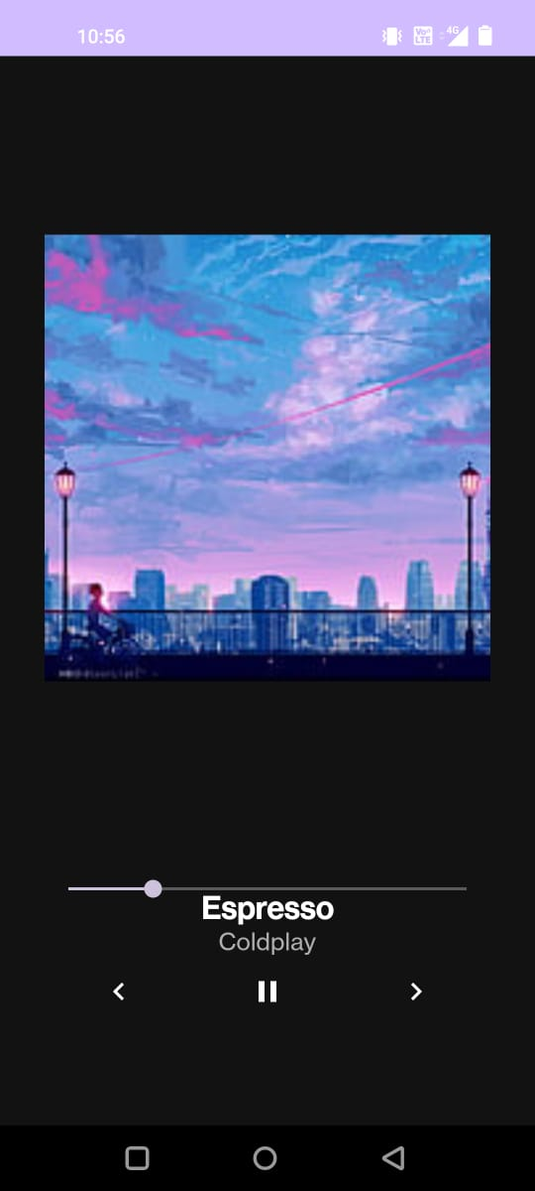

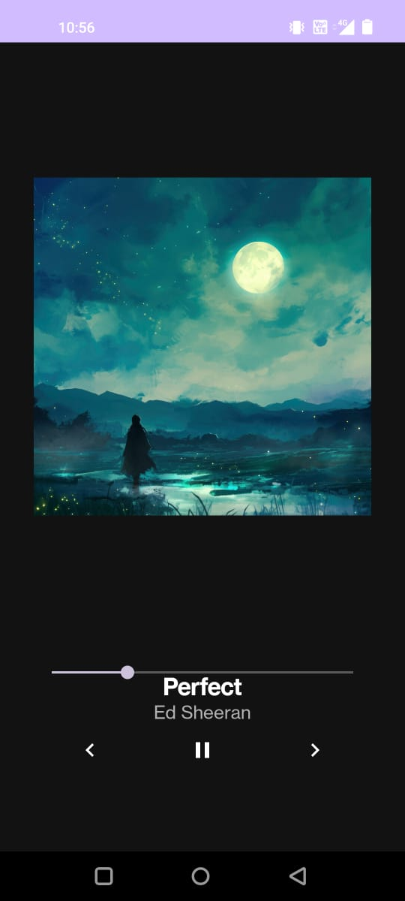

CONCLUSION:

……………………………………………………………………………………………

……………………………………………………………………………………………

……………………………………………………………………………………………



